Name: Ningyuan Zhang

Section: K

Instructor: Joseph Zambreno

Date: 10/3/2016

Home Work #4 Solutions

1).

(a)

input: 12, output: 144

input: 5, output: 5

input: 10, output: 55

(b)

//t0 = 0;

//t1 = 1; (maybe other numbers)

t4 = input;

while(t4 >= 1){

t5 = t0 + t1;

t0 = t1;

t1 = t5;

t4 -= 1;

}

output = t0;

(c)

attached in zip

(d)

attached in zip

2).

(a)

attached in zip

(b)

attached in zip

3).

(a)

sll $a2, $a2, 2 #Init size of array1 in $a2

sll $a3, $a3, 2 #Init size of array2 in $a3

add $v0, $zero, $zero #Init counter counter of array1

add $t0, $zero, $zero #init index of array1

outer:

add $t4, $a0, $t0 #Read next word from array1

lw $t4, 0($t4) #

add $t1, $zero, $zero #init index of array2

inner:

add $t3, $a1, $t1 #Read words from array2, compare

lw $t3, 0($t3) #with word read in outer loop

bne $t3, $t4, skip #If equal, increase counter else

addi $v0, $v0, 1 #continue to compare other words

#in array2

skip:

addi $t1, $t1, 4 #

bne $t1, $a3, inner #Update the index into array1 and

addi $t0, $t0, 4 #array2

bne $t0, $a2, outer #

$v0 returns the number of pairs (n1,n2) where n1 and n2 are elements in array1 and array2 resp. Such that n1=n2 including duplicates.

(b)

outer loop has 3 instructions before inner, and 2 after inner. cycles needed for these are 1 + 2 +1 = 4 and 1 + 2 = 3, total 7 which is 7 \* 2500 after repeat. inner loop needs 1 + 2 + 2 + 1 + 1 + 2 = 9, repeats 2500 \* 2500 times, which is 9 \* 2500 \* 2500. total cycles needed are 56267500 which is adding them together. overall time needed is 56267500/(2\* 10^9) = 28ms.

4).

(a)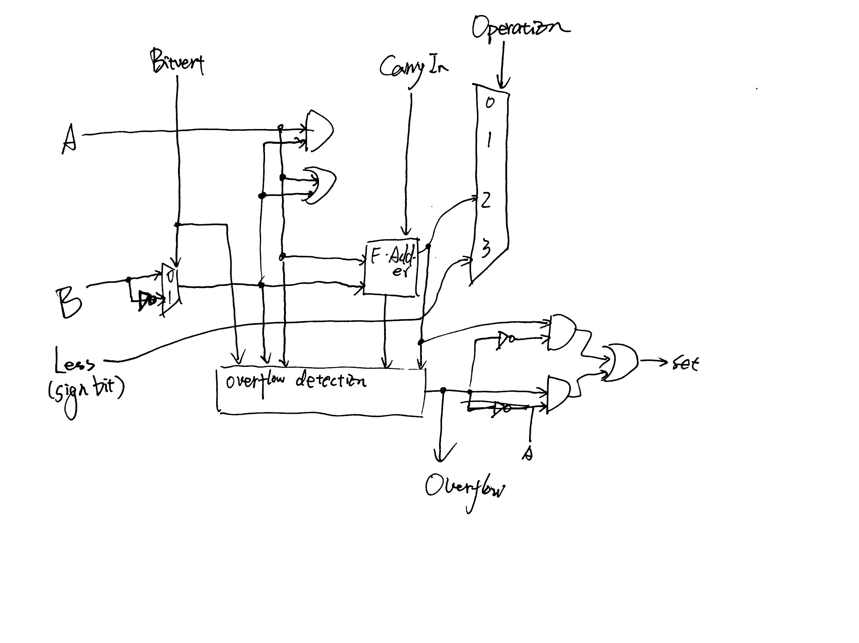

(b)

X < Y : x2'y2 + x2'y2'x1'y1+ x2 y2 x1'y1 + x2'y2'x1'y1'x0'y0 + x2'y2'x1 y1 x0'y0 + x2 y2 x1'y1'x0'y0 + x2 y2 x1 y1 x0'y0

X < Y (signed) : x2 y2' + x2'y2'x1'y1 + x2 y2 x1'y1 + x2'y2'x1'y1'x0'y0 + x2'y2'x1 y1 x0'y0 + x2 y2 x1'y1'x0'y0 + x2 y2 x1 y1 x0'y0

X = Y : x2’ x1’ x0’y2’ y1’ y0’ + x2’ x1’ x0 y2’ y1’ y0 + x2’ x1 x0’ y2’ y1 y0’ + x2’ x1 x0 y2’ y1 y0 + x2 x1’ x0’ y2 y1’ y0’ + x2 x1’ x0 y2 y1’ y0 + x2 x1 x0’ y2 y1 y0’ + x2 x1 x0 y2 y1 y0

(c)